HIP & KNEE REPLACEMENT GUIDE
Helping You Return to the Life and Activities You Love

WHO IS A CANDIDATE FOR JOINT REPLACEMENT?
Joint replacement may be recommended for patients who have:
- Moderate to severe arthritis on X-rays
- Daily pain that limits activities and quality of life
- Failed at least 3 months of non-operative treatment
- Patients with optimized modifiable risk factors. Example: diabetes well controlled, abstinence from tobacco and nicotine, healthy weight loss if BMI >35

TOTAL KNEE REPLACEMENT

Total knee replacement is recommended when more than one knee compartment is “worn out”, due to arthritis or other causes. During surgery, damaged cartilage and worn joint surfaces are removed and replaced with metal and highly durable plastic components. The goal is to relieve pain, restore alignment, improve function, and allow return to everyday activities.

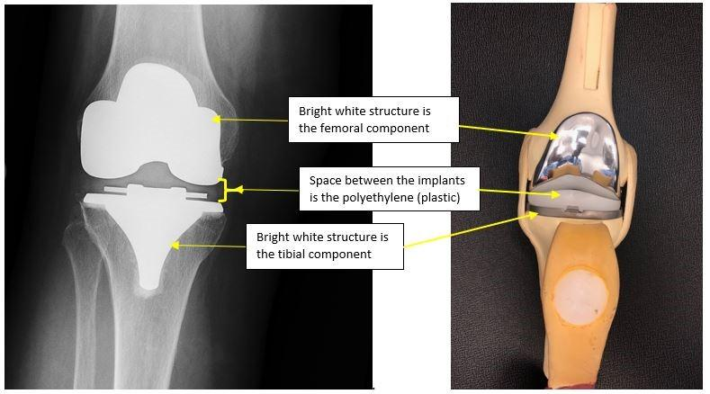


TOTAL HIP REPLACEMENT
Total hip replacement is recommended for end-stage hip arthritis and other conditions such as avascular necrosis, fracture, hip dysplasia, or even tumors. The damaged ball-and-socket joint is replaced with metal, ceramic, and plastic components designed to restore motion, improve function, and relieve pain.

Hip Replacement Approaches
Both direct anterior and posterolateral approaches provide excellent long-term outcomes. When possible, Dr Vaux utilizes the anterior approach because studies show the benefit of faster early recovery and no need for hip precautions.

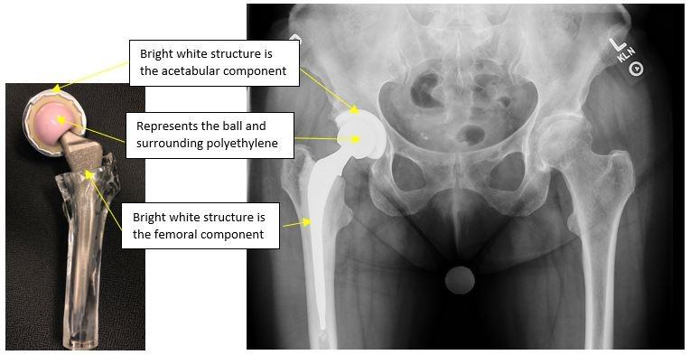

NON-SURGICAL TREATMENT OPTIONS
Before considering surgery, many patients benefit from conservative treatment

Medications:
- Anti-inflammatory medications (NSAIDs)
  - Examples include: ibuprofen (Motrin or Advil), naproxen (Aleve), meloxicam/mobic (prescription), Voltaren (diclofenac, topical ointment
  - These medications help reduce pain and inflammation but should be used cautiously in patients with kidney disease, stomach ulcers, heart disease, or those taking blood thinners.
- Acetaminophen (Tylenol)
  - Tylenol can be as effective for arthritis pain and is often safer than NSAIDs. Maximum recommended dose is generally 3,000 mg daily unless otherwise directed.
- Narcotics
  - We do not recommend narcotic medications for arthritis treatment because they do not address inflammation and are associated with significant risks.

Injections:
- Cortisone (steroid) injections
  - Can provide temporary pain relief and reduce inflammation but do not treat the underlying arthritis. Relief duration varies significantly between patients. For some patients, these injections can last 6 months and for others, only 1-2 days. Additionally, they can cause cartilage damage, particularly within the hip joint.
- Hyaluronic Acid (“Gel”) Injections
  - These injections may improve joint lubrication and provide symptom relief for selected patients. Relief duration and response is also variable.
- PRP (Platelet Rich Plasma) Injections
  - PRP (Platelet-Rich Plasma) injections use a small sample of your own blood to concentrate natural growth factors that may help reduce pain and inflammation in some patients with mild to moderate knee arthritis. PRP does not regrow cartilage or cure arthritis, and results vary from person to person. It is often not covered by insurance

*Important: If you receive a hip or knee injection, surgery will be delayed in most cases for at least 3 months due to increased infection risk.
.

Weight Loss:

Weight loss can significantly reduce joint pain. Because the hip and knee experience forces several times body weight during daily activities, losing even 5-10 pounds can substantially decrease stress across the joint. Safe weight loss also lowers surgical complication rates.

Exercise & Physical Therapy:
Exercise and physical therapy can improve flexibility, strength, balance, reduce pain and improve function. However, in advanced bone-on-bone arthritis, some exercises may temporarily increase symptoms.

Braces:

Braces may provide support and symptom relief for selected patients, particularly those who have significant deformity or are not surgical candidates.

FREQUENTLY ASKED QUESTIONS

Will I Stay Overnight? More than 80% of patients go home the same day. Once pain is controlled, walking is safe, therapy goals are met, and you are medically stable, recovery at home is often safest.

What Is Recovery Like? Typical progression:
- Walker: approximately 1-2 weeks
- Cane: approximately 1-3 weeks
- Independent walking: often by 4-6 weeks
- Significant recovery: approximately 3 months (resume activities such as hiking, weights, pickleball)
- Continued improvement: up to 1 year

When Can I Walk? Immediately after surgery. Your new joint is designed to support your weight right away unless special restrictions are required.

When Can I Drive? Usually 3-4 weeks after surgery when:
- No longer taking narcotic pain medication
- No longer dependent on a walker or cane
- Able to safely operate the vehicle

When Can I Travel? After your first postoperative appointment. During long trips, stand, walk, or stretch at least once per hour to reduce blood clot risk.
When Can I Return to Work? Most patients should anticipate being off work approximately 6 weeks.
- Desk jobs: often 2-6 weeks
- Physical jobs: often 10-12 weeks

What Activities Are Allowed? Recommended low-impact activities include: Walking, Hiking, Golf, Gardening, Cycling, Swimming, Doubles tennis / pickleball. High-impact activities such as running and jumping may increase wear on implants and should generally be avoided for at least 4 months after surgery.
Why Does My Incision Feel Numb? Temporary numbness around the incision is common and often improves during the first year.
Why Does My Knee Click? A clicking sensation after knee replacement is common and usually reflects normal interaction between the implant components.
Can I Kneel After Knee Replacement? Yes. Kneeling may initially be uncomfortable but generally does not harm the implant.
Will My Leg Feel Longer? Small differences can occasionally occur, particularly after hip replacement, but are often necessary to maximize stability and decrease the risk of dislocation. Lengthening after knee replacement is uncommon, unless there was a dramatic deformity before surgery. If there is a leg length discrepancy, most patients adapt naturally after surgery.
What Type of Anesthesia Is Used? Most patients receive spinal anesthesia with light sedation, although general anesthesia may be used when appropriate.
What Results Should I Expect?
The majority of patients experience less pain and more mobility in their joint, and can resume most of the activities they enjoyed before the onset of arthritis. Long-term studies show that over 90% of artificial joints are intact and fully functional after 10-years and 80-85% at 20 years. Your artificial joint will last longer if you maintain a healthy weight, active lifestyle, medical conditions are well controlled.

Day of Surgery: Before discharge, patients should:
- Walk safely with a walker
- Tolerate food and fluids
- Have pain controlled
- Have stable vital signs

Weeks 1-2
- Walk frequently, using walker or cane
- Ice regularly
- Take medications as directed
- Perform “Big 3” home exercises

Weeks 2-6
- Transition to cane as tolerated
- First postoperative visit
- Begin outpatient therapy if indicated
- Resume driving when appropriate

Weeks
- Continue to increase range of motions, strength and walking endurance
- Progress activity as tolerated
- Second post op visit; Follow-up X-rays obtained

3 Months
- Return to most daily activities and other activities you enjoy, including: hiking, golf, cycling, pickleball, strength training, travel
- Significant improvement in function and stamina

6 Months
- Continued improvement in strength and endurance

- Year
- Most patients have achieved the majority of their recovery, although strength, endurance, and confidence can continue to improve beyond one year.

RISKS OF JOINT REPLACEMENT SURGERY
Serious complications are uncommon, occurring in approximately 2% or less of patients. While complications are uncommon, all surgery carries risk. Joint replacement surgery is a major surgery with potential complications, including:
- Infection (1-2%)
- Blood clots
- Bleeding or hematoma
- Wound healing problems
- Persistent pain
- Stiffness or limited motion
- Nerve or blood vessel injury
- Implant loosening or failure
- Fracture around the implant
- Medical complications such as heart attack, stroke, pneumonia, or death
- Need for revision surgery
Most complications are rare, and we work extensively to minimize risk through medical optimization and modern surgical techniques.
*The risks above occur rarely. But we want all of our patients to know ahead of time that this surgery is a major surgery, and that even for the healthiest and fittest patients, things can unfortunately go wrong. Again, despite all of the risks and potential complications, 80-90% of patients are happy they had their surgery done and consider their quality-of-life improved.

WHAT HAPPENS IF I NEED A “RE-DO”?

REVISION TOTAL JOINT REPLACEMENT:

Joint replacements are designed to last many years, but occasionally additional surgery is necessary due to infection, loosening, instability, fracture, or implant wear. Revision surgery is more complex and requires specialized evaluation and treatment.

Revision Joint Replacement for Prosthetic Joint Infection (PJI):

An uncommon, but dreaded complication after a total joint replacement, is a prosthetic joint infection (PJI). This is an infection deep in the joint replacement. Despite optimization and strict protocols, some patients still may develop a PJI, even many years after a successful joint replacement. Prosthetic joint infections can be difficult to treat and can require multiple surgeries to control the infection, in conjunction with antibiotics. Patients who are diabetic, smokers, have autoimmune disease or other chronic health problems, are at higher risk.

If this occurs, you may require complete removal of all the joint components and placement of an antibiotic spacer. You will then be placed on IV antibiotics for 6 weeks, in conjunction with an infectious disease specialist, often with longer oral antibiotics.

For more information, please visit:
https://hipknee.aahks.org/revision-knee-replacement/

NEXT STEPS CHECKLIST
□ Call Surgery Scheduler: 208-302-3500
You will select a date for surgery and also be scheduled for a pre-admission testing appointment, a pre-op appointment with your surgeon and two post op appointments (2 weeks & 6 weeks). At the 2 week appointment we will check your incision and motion, and xrays will be obtained at the 6 week appointment to evaluate your joint replacement.
□ Select a Caregiver/Coach
We recommend that you have a caregiver stay with you 24/7 for a minimum of 2-3 days after you return home from surgery, and someone who can check in on you or help for 7-10 days post op. We recommend a family member or close friend. Your caregiver/ coach often:
- Accompanies you to pre and post-operative visits (medical, surgical, physical therapy)
- Transports you to the hospital on the day of surgery
- Stays with you after surgery as you recover
□ Complete Pre-Admission Testing (2-3 weeks before surgery)
This appointment is scheduled for you at the time of surgery scheduling. You will meet with a Nurse Practioner from the hospitalist team who will help with medical co-management, obtain lab work, an EKG, if necessary, discuss any medical problems and ensure you are medically optimized for surgery. You will also be instructed on surgical prep and medication use prior to surgery.
□ Complete Required Dental Work
Cancel any dental appointments 1 month PRIOR to surgery and 3 months AFTER surgery. If you have any loose teeth or dental work that needs to get done, let us know IMMEDIATELY.
□ Attend Joint Camp (attend in person or online):
www.orthojointclass.com
□ Attend Preoperative Appointment
Scheduled 1-2 weeks prior to surgery, to discuss surgical plan, review labs and medical clearance, discuss post op plan and medications. If you can, please try to bring your coach/ caregiver.

A successful joint replacement should help you return to an active, healthy lifestyle—not simply survive arthritis.

ADDITIONAL RESOURCES:
www.jonathanvauxdo.com


Joint Camp QR Code:


